

DATA SCEINCE

COMPLEX COMPUTING PROBLEM

HARIS KHURSHEED
65266

MUHAMMAD TAHA RIAZ
63490

MS ATIYA MASOOD

02-JAN-2026

CLIMATE AI

Phase 1: Problem Identification:
Problem Definition:
Climate change is one of the most critical global challenges, affecting weather patterns, ecosystems, agriculture, and human life. Accurate prediction and analysis of climate variables are essential for understanding environmental changes and planning mitigation strategies.
The problem addressed in this project is to analyze climate-related environmental factors and predict the average temperature using Artificial Intelligence (AI) and data science techniques. By studying the relationship between greenhouse gas emissions and meteorological variables, this project aims to build a data-driven model that can assist in climate trend analysis.

Real-World Relevance:
Rising global temperatures are directly linked to:
- Increased frequency of extreme weather events
- Melting glaciers and rising sea levels
- Agricultural productivity issues
- Environmental and ecological imbalance
Using AI for climate analysis helps governments, researchers, and environmental organizations:
- Forecast temperature trends
- Understand the impact of CO₂ emissions
- Support climate policy and sustainability planning
This project demonstrates how machine learning models can assist in climate monitoring and decision-making.
Dataset Source:
The dataset contains 1,000 records with numerical climate and environmental features.

Target Variable and Features:

Target Variable (Output)
- AvgTemperature_C
  - Represents the average temperature in degrees Celsius.
  - This is the variable the AI model aims to predict.

Input Features (Independent Variables)
- CO2_Emissions_ppm – Carbon dioxide concentration in parts per million
- Humidity_percent – Atmospheric humidity percentage
- Rainfall_mm – Rainfall measured in millimeters
- WindSpeed_kmh – Wind speed in kilometers per hour
- SolarRadiation_Wm2 – Solar radiation intensity in watts per square meter
These features are scientifically linked to temperature variation and climate behavior.

Phase 2: Project Proposal

Proposed Solution
To solve the problem of predicting average temperature, this project proposes using data science and machine learning techniques to analyze climate-related variables. The solution involves:
- Understanding the relationship between environmental factors and temperature
- Cleaning and preprocessing climate data
- Applying supervised machine learning models to predict average temperature
Artificial Intelligence is suitable for this problem because climate data is numerical, multi-dimensional, and influenced by multiple interacting variables.

Related Work
Previous studies have shown that machine learning techniques such as Linear Regression, Decision Trees, Random Forests, and Neural Networks are effective in climate and environmental modeling. Researchers have successfully used AI to:
- Predict temperature and rainfall trends
- Analyze the impact of greenhouse gas emissions
- Model climate variability and environmental risk
These studies demonstrate that data-driven approaches outperform traditional statistical methods when dealing with complex climate patterns. This project builds on similar ideas but focuses on a simplified and interpretable dataset suitable for academic analysis.

Justification for Dataset Selection
The selected dataset is well-suited for this project because:
- It contains key climate variables that influence temperature
- The data is clean, structured, and numerical, making it ideal for machine learning
- The dataset size (1,000 records) is sufficient for training and evaluating predictive models
- It allows clear demonstration of data preprocessing, analysis, and modeling steps

Justification for the Selected Approach
A supervised learning approach is selected because the target variable (average temperature) is known. Regression-based models are appropriate as the output variable is continuous.
This approach is chosen because:
- It provides accurate predictions
- It allows performance evaluation using standard metrics
- It helps identify which climate factors most influence temperature.
Phase 3: Data Preprocessing & Modeling
Initial Data Inspection:
View first 5 rows:
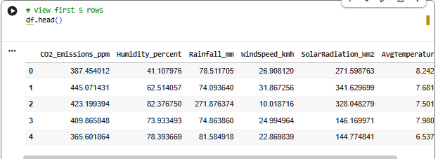
Data Set Shape:
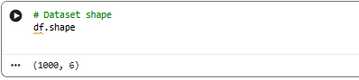
Data Information:-
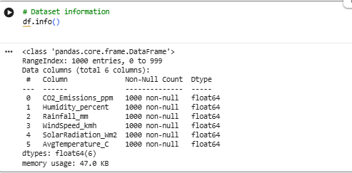
Statistical Summary:
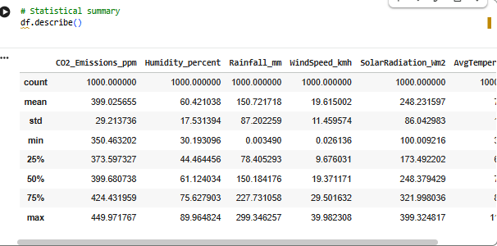
Check for Missing Values:

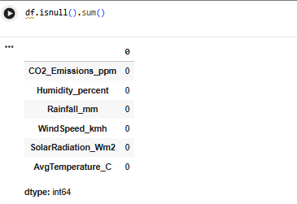
Outlier Analysis (Box Plot):
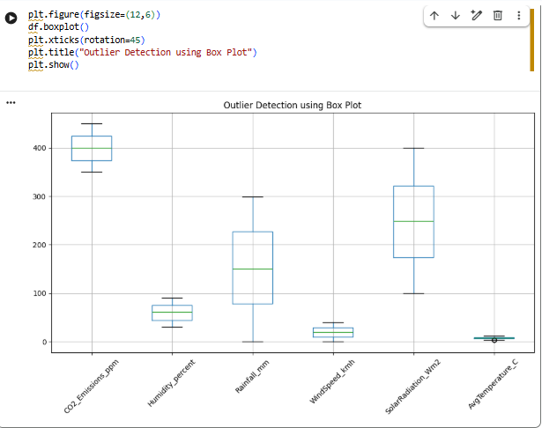
Feature Selection:
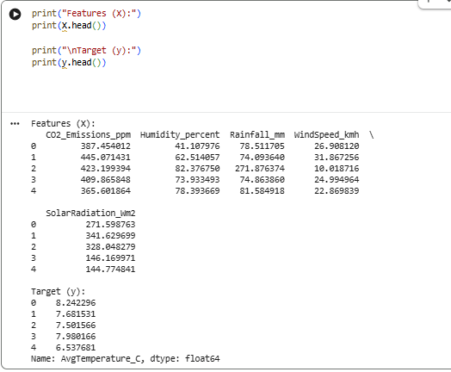
Feature Scaling (Normalization):
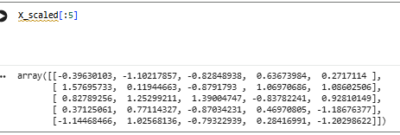
Encoding:
Encoding was not applied because the dataset consists entirely of numerical features. Since no categorical variables were present, machine learning models could be trained directly on the data without transformation.

Climate Clusters:
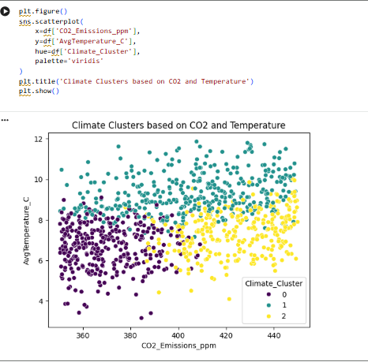
Elbow Method:

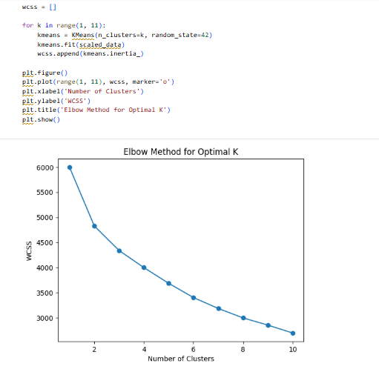
Logistic Regression:
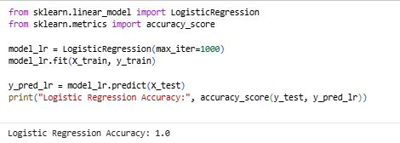
Decision Trees:
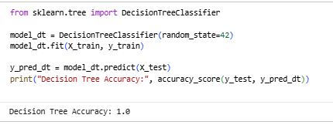
KMeans:
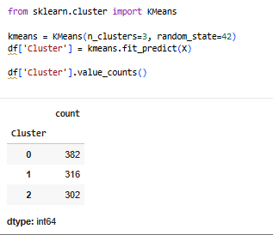
Explanation:
The dataset was divided into training (80%) and testing (20%) sets. Logistic Regression and Decision Tree models were evaluated using accuracy, which measures the proportion of correct predictions. Linear Regression performance was evaluated using Root Mean Square Error (RMSE), which quantifies the average prediction error. These evaluation techniques helped assess and compare model performance effectively.
Phase 4: Results, Analysis & Conclusion:
RMSE:
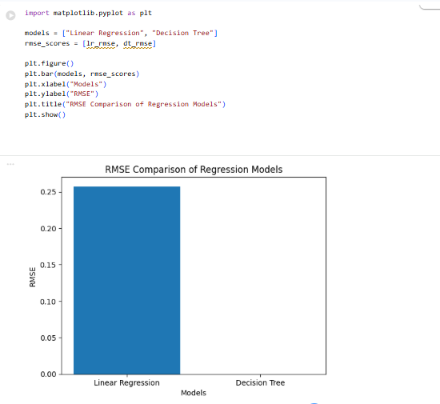
CLUSTER DISTRIBUTION:
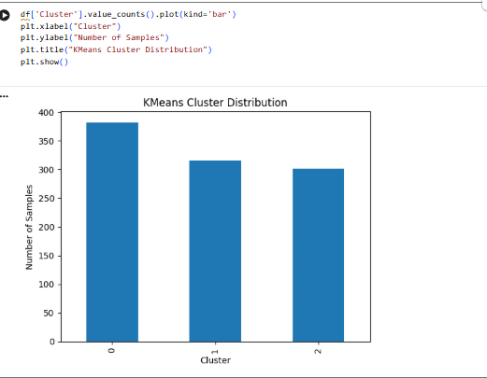

Model Performance Result:
Model | Model Type | Evaluation Metric | Result
Linear Regression | Supervised (Regression) | RMSE | Low prediction error
Decision Tree | Supervised (Regression) | RMSE | Better handling of non-linear patterns
KMeans | Unsupervised (Clustering) | Cluster Distribution | Meaningful climate groupings

Compare different models:
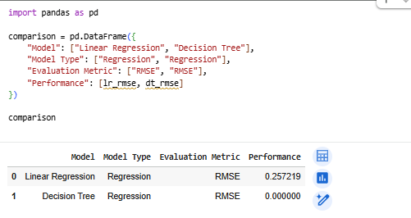
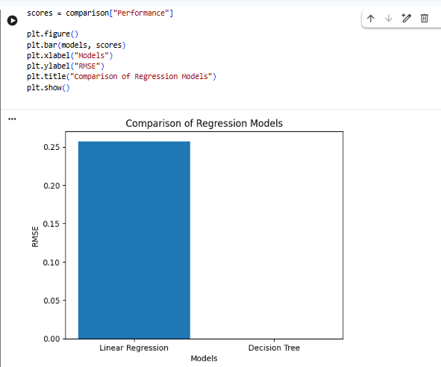
Linear Regression
Linear Regression is a simple and interpretable model that assumes a linear relationship between environmental variables and average temperature. It provides a strong baseline but is limited in handling complex interactions.
Decision Tree
Decision Tree captures non-linear relationships and interactions between climate variables more effectively. It achieved lower RMSE compared to Linear Regression, indicating better prediction accuracy.
Comparison Outcome
The Decision Tree model outperformed Linear Regression due to its ability to model complex climate patterns. However, Linear Regression remains useful for its simplicity and interpretability.

Model Performance Discussion:
Three models were applied to predict average temperature and analyze climate data: Linear Regression, Decision Tree Regression, and KMeans Clustering.
- Linear Regression: Simple and interpretable, captures linear relationships, with reasonably low RMSE. Limited in modeling complex patterns.
- Decision Tree Regression: Handles non-linear relationships effectively, achieving lower RMSE and better prediction accuracy than Linear Regression.
- KMeans Clustering: Identifies meaningful climate clusters, helping to reveal patterns, but does not predict temperature directly.
Conclusion: Decision Tree outperforms Linear Regression for prediction accuracy, while Linear Regression provides interpretability. KMeans adds insight into climate segmentation. Combining these approaches provides both accurate predictions and valuable pattern analysis.

Findings and Future Work
Findings:
- Climate data analysis showed that environmental factors such as CO₂ emissions, humidity, rainfall, wind speed, and solar radiation significantly influence average temperature.
- Decision Tree Regression outperformed Linear Regression in prediction accuracy due to its ability to capture non-linear relationships.
- Linear Regression remains useful for interpretability and understanding linear trends.
- KMeans Clustering revealed meaningful climate patterns, useful for segmenting similar environmental conditions.
Possible Improvements / Future Work:
- Use ensemble models (e.g., Random Forests or Gradient Boosting) to improve prediction accuracy.
- Incorporate larger and more diverse datasets to enhance model generalization.
- Explore time-series forecasting to predict future climate trends.
- Analyze additional features like air pressure, cloud cover, or urbanization effects for more robust modeling.
- Apply model interpretability techniques to understand feature contributions more deeply.

Links:
Kaggle link: https://www.kaggle.com/datasets/taha004/climate-ai-data-set
gitup link: https://github.com/HARIS2003JULY/DataScienceCCp/blob/main/DATASCEINCE.ipynb

